**EXPERIMENT 12:-**

**AIM:**

DEMONSTRATE INFRASTRUCTURE AS A SERVICE(IAAS) BY CREATING A VIRTUAL MACHINE USING A PUBLIC CLOUD SERVICE PROVIDER(AZURE/GCP/AWS) CONFIGURE WITH MINIMUM CPU,RAM AND STORAGE AND LAUNCH THE VM IMAGE.

**PROCEDURE:**

1.Goto Microsoft Azure.

2.login to your account.

3.Create a Virtual Machine with your ip address an Username and Password for your Virtual Machine.

4.Deploy your Virtual Machine.

5. Now Connect The Virtual Machine and download The RDP File to open Your Windows Virtual Machine.

6.A new Windows Virtual Machine is Created.

**IMPLEMENTATION:**

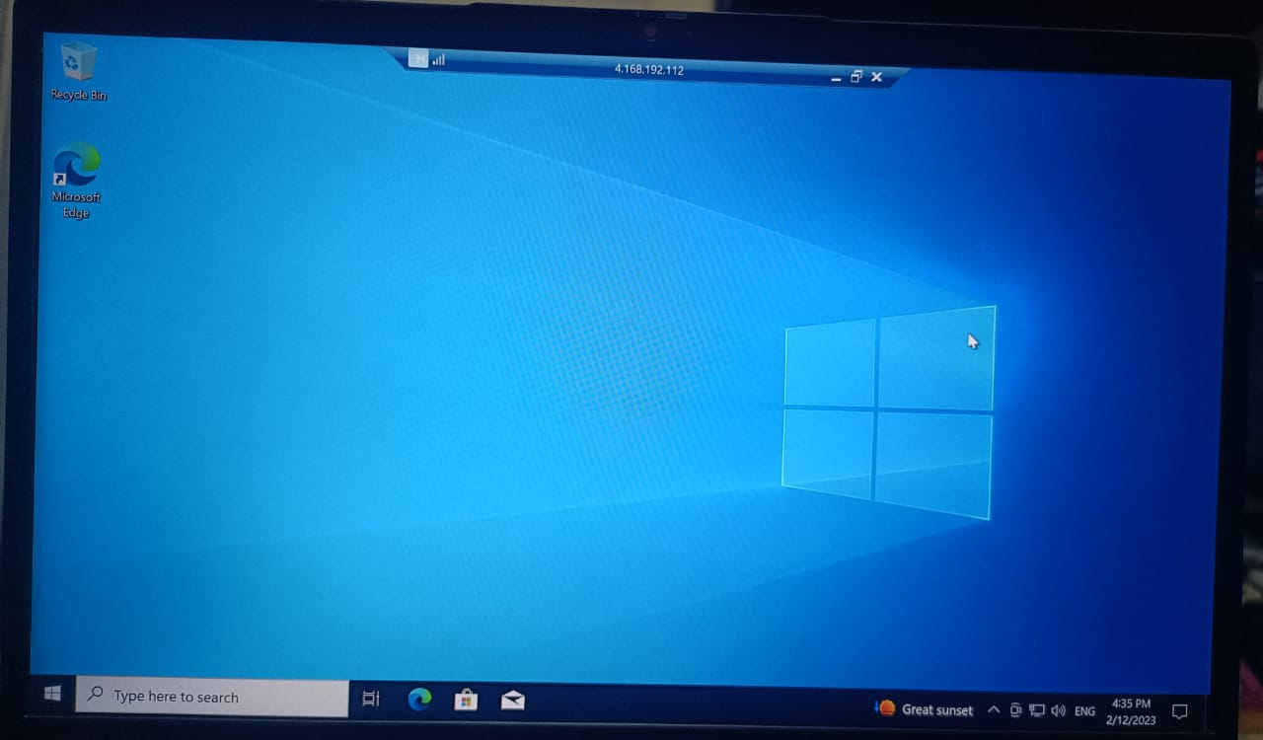

**EXPERIMENT 13:-**

**AIM:**

CREATE A SIMPLE WEB SITE USING ANY PUBLIC CLOUD SERVICE PROVIDER (AZURE/GCP/AWS) AND CHECK THE PUBLIC ACCESSIBILITY OF THE STORED FILE TO DEMONSTRATE STORAGE AS A SERVICE.

**PROCEDURE:**

1.Goto Microsoft Azure.

2.login to your account.

3.Create App Services with run stack as NODE 14 LTS and OS as LINUX and click on Review+Create.

4.Click on Create and Deploy your app service.

5.Once the deployment is done goto resource and click on URL.

6.A new web page is opened.

**IMPLEMENTATION:**

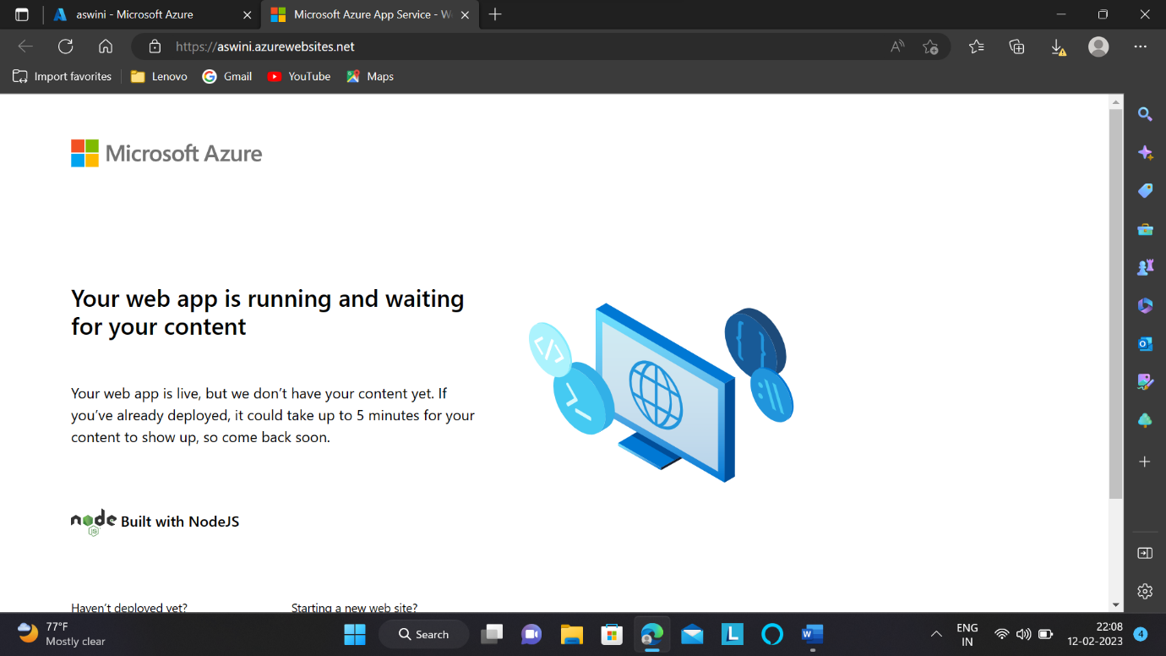

**EXPERIMENT 14:-**

**AIM:**

CREATE A STORAGE SERVICE USING ANY PUBLIC CLOUD SERVICE PROVIDER (AZURE/GCP/AWS) AND CHECK THE PUBLIC ACCESSIBILITY OF THE STORED FILE TO DEMONSTRATE STORAGE AS A SERVICE.

**PROCEDURE:**

1.Goto Microsoft Azure.

2.login to your account.

3.Create Storage Accounts and Enter the necessary information and Click on Review+Create.

4.Click on create and your storage account is deployed.

5.goto Containers and add a Container and upload an C code.

6.The code is stored.

7.You can access your code whenever required.

**IMPLEMENTATION:**

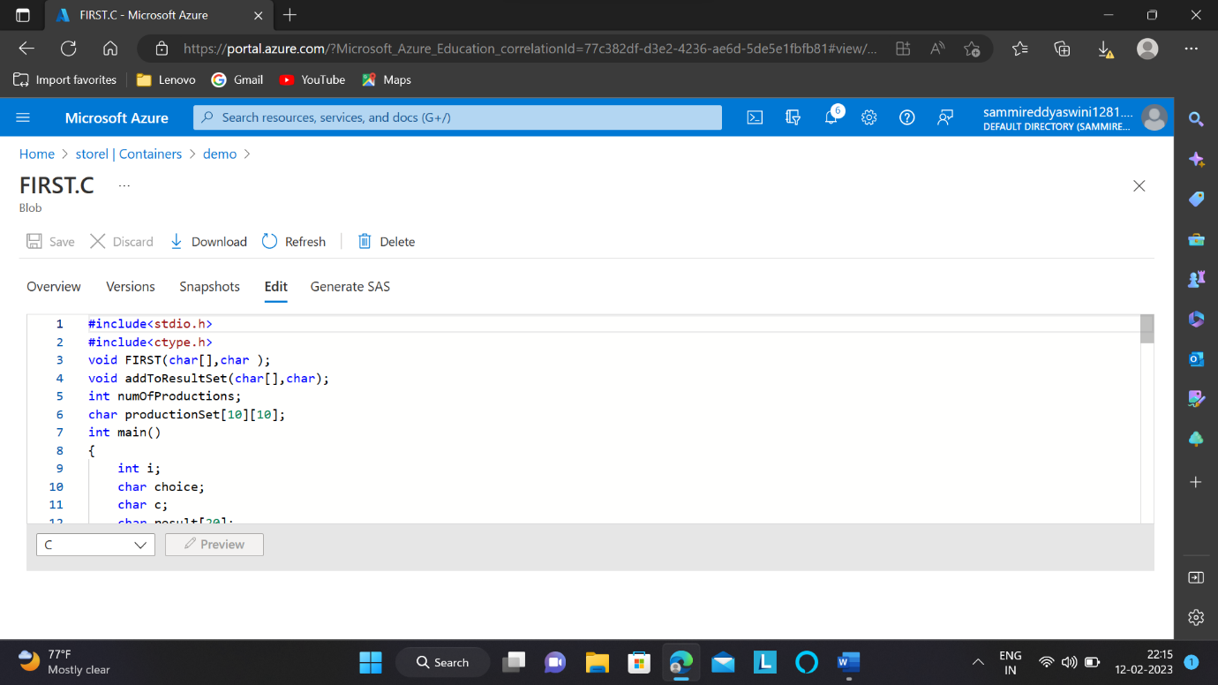

**EXPERIMENT 15:-**

**AIM:**

CREATE A SQL STORAGE SERVICE AND PERFORM A BASIC QUERY USING ANY PUBLIC CLOUD SERVICE PROVIDER (AZURE/GCP/AWS) TO DEMONSTRATE DATABASE AS A SERVICE (DAAS)**.**

**PROCEDURE:**

1.Goto Microsoft Azure.

2.login to your account.

3.Create SQL databases and enter a valid server name and change the location to UK South along with username and password.

4.In Additional Settings Select Sample.

5.Click on Create and deployment is done.

6.Click on Configure change to Saved Networks and allow the acess and save it.

7.goto query editor enter username and password and select ok.

8.click on url shown and then again click on ok.

9.Sql database is opened and our tables are shown.

10.Type a query to execute and output is produced.

**IMPLEMENTATION:**

